Supplies form
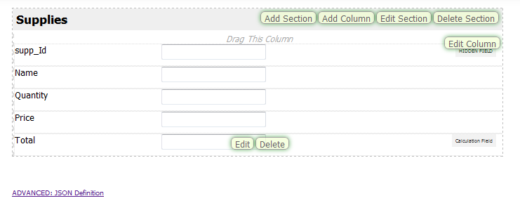
Supplies list
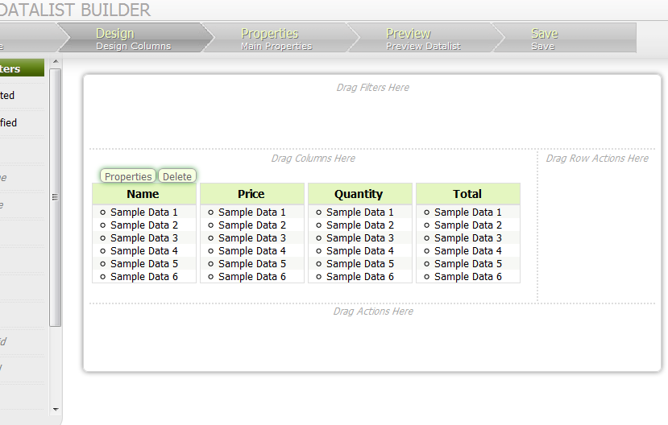

Total
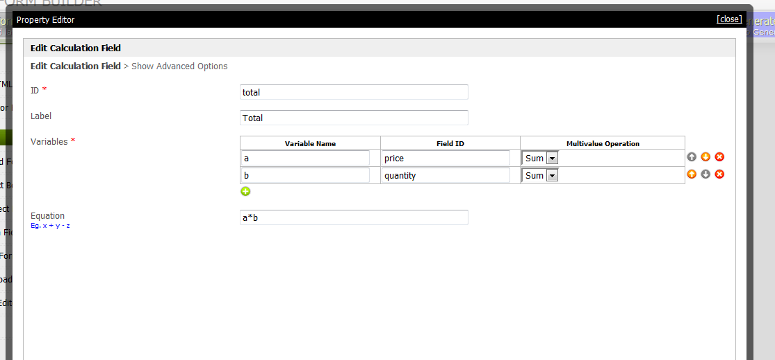

List grid
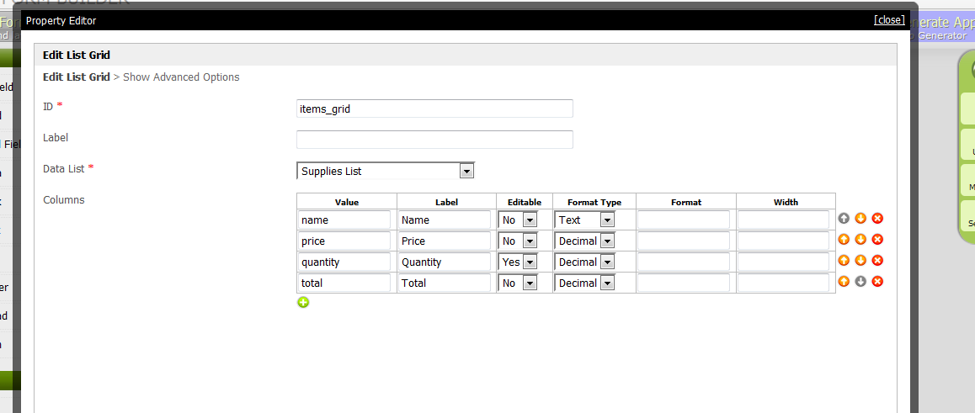

Grand total
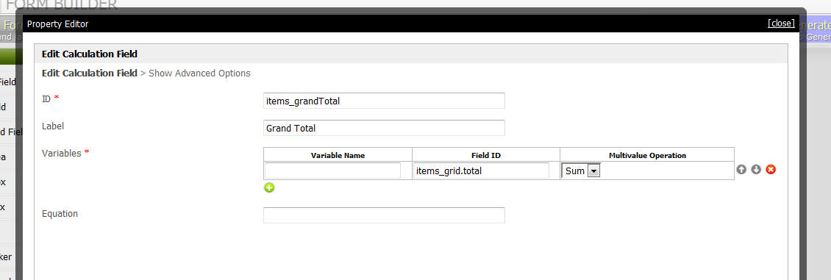

Order Interface
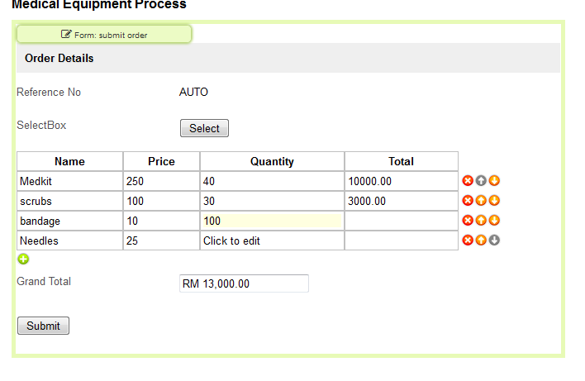
PROBLEM:
Inputed supply was in the form e.g. medkit was 250 and 40 quantity gives u total 10000
once you jus select bandage with price 10 and edit quantity to 100 the total doesn’t reflect and hence
the addition becomes invalid so as said I cannot change the list grid put my own quantity jus a display screen not updating quantity to total….

