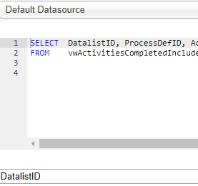
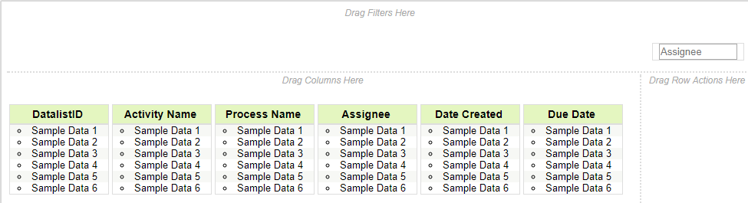
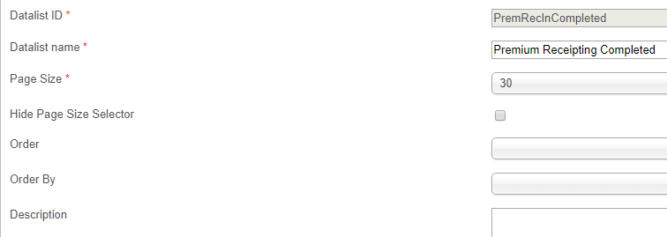
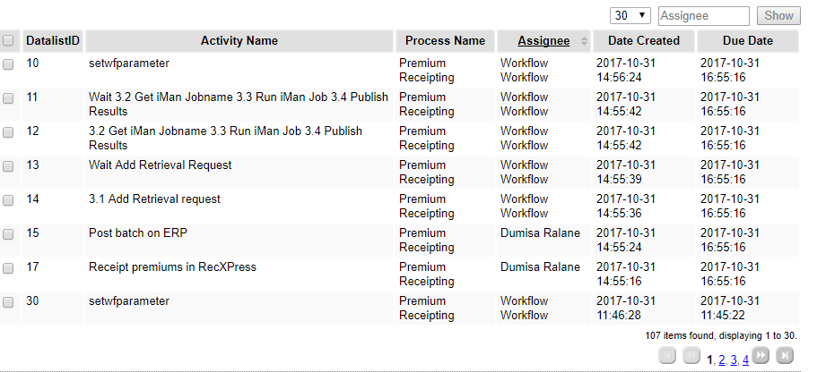

{"id":"PremRecInCompleted","name":"Premium Receipting Completed","pageSize":"30","order":"","orderBy":"","showPageSizeSelector":"true","pageSizeSelectorOptions":"10,20,30,40,50,100","buttonPosition":"bottomLeft","checkboxPosition":"left","useSession":"false","rowActions":[],"description":"","filters":[{"name":"Assignee","id":"filter_2","label":"Assignee"}],"hidePageSize":"","actions":[],"binder":{"className":"org.joget.plugin.enterprise.JdbcDataListBinder","properties":{"jdbcDatasource":"default","sql":"SELECT DatalistID, ProcessDefID, ActivityInstanceID, ActivityName AS 'Activity Name', ActivityLink as 'Activity Link', ProcessName AS 'Process Name', Assignee, ActivityStatus, DateCreated AS 'Date Created', DueDate AS 'Due Date', QuoteCode AS 'Quote Code', AcceptedQuoteRef AS 'Accepted Quote Ref'\nFROM vwActivitiesCompletedIncludeSystems where ProcessDefID = 'premiumreceipting'\n\n","primaryKey":"DatalistID"}},"columns":[{"id":"column_0","label":"DatalistID","displayLabel":"DatalistID","name":"DatalistID"},{"displayLabel":"Activity Name","name":"Activity Name","id":"column_4","label":"Activity Name"},{"displayLabel":"Process Name","name":"Process Name","id":"column_7","label":"Process Name"},{"hidden":"false","name":"Assignee","width":"","format":{"className":"","properties":{}},"action":{"className":"","properties":{}},"style":"","id":"column_2","label":"Assignee","sortable":"true","exclude_export":""},{"hidden":"false","name":"Date Created","width":"","format":{"className":"org.joget.plugin.enterprise.DateFormatter","properties":{"dataFormat":"yyyy-MM-dd HH:mm:ss","displayFormat":"yyyy-MM-dd HH:mm:ss"}},"action":{"className":"","properties":{}},"style":"","id":"column_5","label":"Date Created","sortable":"false","exclude_export":""},{"hidden":"false","name":"Due Date","width":"","format":{"className":"org.joget.plugin.enterprise.DateFormatter","properties":{"dataFormat":"yyyy-MM-dd HH:mm:ss","displayFormat":"yyyy-MM-dd HH:mm:ss"}},"action":{"className":"","properties":{}},"style":"","id":"column_6","label":"Due Date","sortable":"false","exclude_export":""}]}

